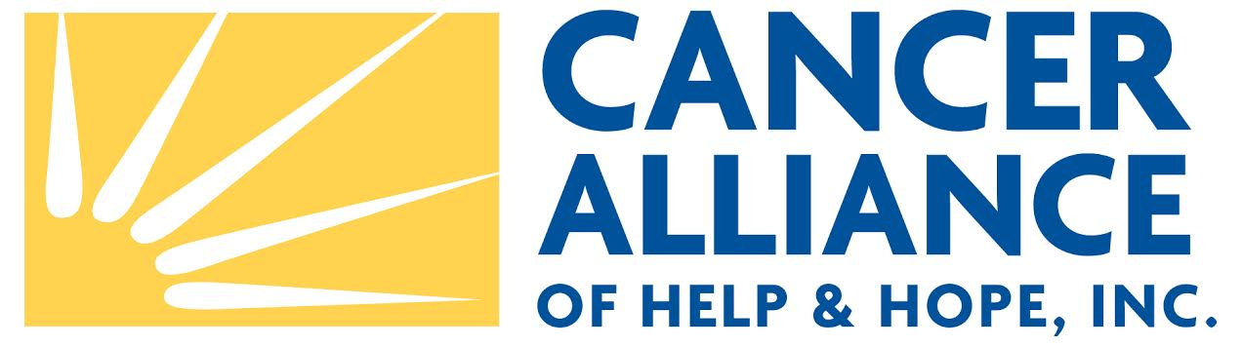

Financial Assistance Application Guidelines

Please fill out the enclosed application and send all necessary documents to Cancer Alliance of Help & Hope (CAHH) via regular mail to the address listed below, fax to 561-748-7293, via email to canceralliance@gmail.com, or dropped off to our office in person. Applications cannot be processed until all information and documents are submitted.

To be considered for financial assistance, you must be a resident of Palm Beach County and undergoing infusion chemotherapy or radiation treatment. You must be currently receiving treatment or received treatment in the last four (4) months from the date of your application.

To receive financial assistance from CAHH, please submit the following with your application:

Signed Physician’s Statement of Treatment – this form is enclosed.

Copy of photo ID.

Proof of Household Income: This includes income for anyone 21 years of age or older living in the household who is working. Submit copies of proof of income, such as, pay stubs, letter of determination from Social Security or other agencies, and the like.

Copies of your most recently filed tax return and W-2 statement.

Copies of the last two (2) month’s bank statement for all banks of all individuals, 21 years of age or older living in the household.

Current and complete copies of all monthly expenses being submitted to CAHH for financial assistance such as, utility bills, mortgage statement, copy of lease (include the name and address of landlord), car payment, car insurance and health insurance bills. Please do not send original bills, copies only.

Copies of current monthly expenses, such as, credit card bills, medical expenses, and prescription drug expenses. Although these types of expenses are not eligible for financial assistance from CAHH, we do need to know how much of your income is paid toward them.

Applications will be reviewed at least monthly. Applicants will be notified of CAHH’s decision immediately following the committee meetings. Please feel free to contact our office at 561-748-7227 with any questions.

Sincerely,

Cancer Alliance of Help & Hope

CAHH P.O. Box 3292, Palm Beach, FL 33480 Phone: 561-748-7227
E-mail: canceralliance@gmail.com Web Site: www.cahh.org

Registration #CH16613. A copy of the official registration and financial information may be obtained from the Division of Consumer Services by calling toll-free (800)435-7352 within the state. Registration does not imply endorsement, approval or recommendation by the state.

